User Guide

Introduction
This User Guide will take you step-by-step through the Vacation Planner Mobile Application, showing you every feature offered on every page.

Main Activity Page
Enter the Application:
- Click the ‘Enter’ button to be directed to either the ‘Sign Up’ page or the ‘Log In’ page depending on whether you have already created an account.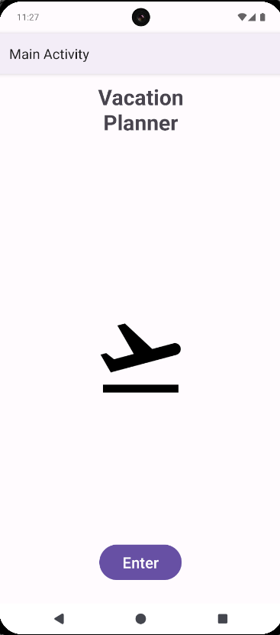

Sign In Page
Create Account:
- First enter a username in the ‘Username:’ input, the username must be at least 6 characters long, have 1 capital letter, and have no spaces (Ex: Tester1).
- Next enter a password in the ‘Password:’ input, the password must be at least 8 characters long, have 1 capital letter, have 1 number, and have no spaces (Ex: Tester1!).
- Then re-enter your password in the ‘Confirm Password:’ input to verify your password before saving it permanently.
- Lastly, click the ‘Sign Up’ button to create your account to go to the ‘Vacation List’ page. If any errors are made you will be prompted to correct them prior to saving your account.
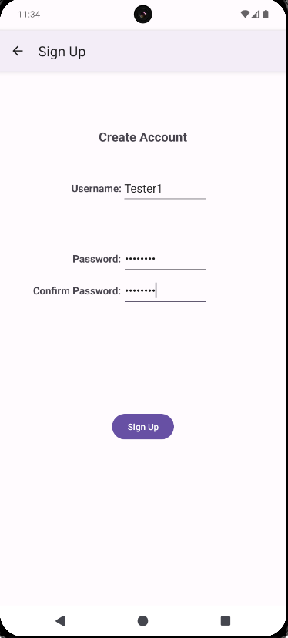

Log In Page
Log In Account:
- Enter your username in the ‘Username’ input.
- Enter your password in the ‘Password:’ input.
- Click the ‘Log In’ button to go to the ‘Vacation List’ page. If any errors are made, you will be prompted to correct them prior to logging in.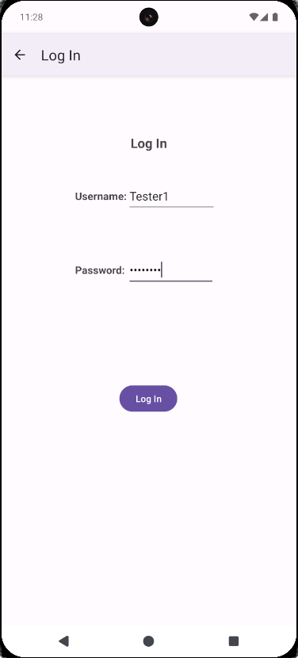

Vacation List Page
Add Vacation:
- To add a vacation, click the ‘+’ button in the bottom right corner of the screen, this will take you to the ‘Vacation Details’ page.
View/Modify Existing Vacation:
- To view/modify an existing Vacation, click on the title of the vacation (Ex: Florida) to go to the ‘Vacation Details’ page of the chosen vacation.
Search Vacation List:
- Set your desired ‘Search By:’ method by clicking the drop-down next to it. You can search your vacations by Title, Hotel, or Transportation Method.
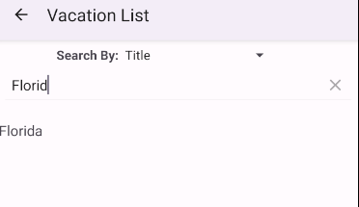
- Click the magnifying glass to bring up your keyboard.
- Start typing what you want to find, and your list of vacations will match your desired result (view screenshot to the right).
Generate Report:
- To generate a report, click the ‘Generate Report’ button which will take you to the ‘Report’ page.
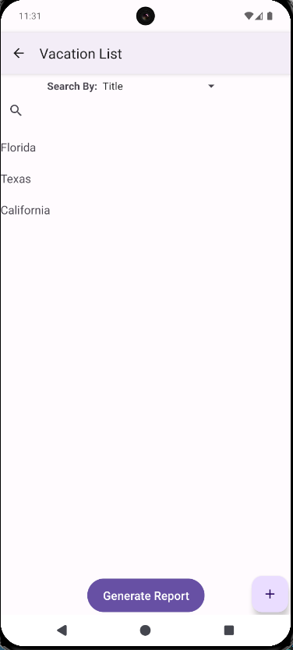

Report Page
View Generated Report:
- Once you have entered this page you can view the report. Each row contains the title, hotel, start date, and end date for every vacation planned.
Go Back to Vacation List:
- Click the ‘Back’ button to return to the ‘Vacation List’ page.
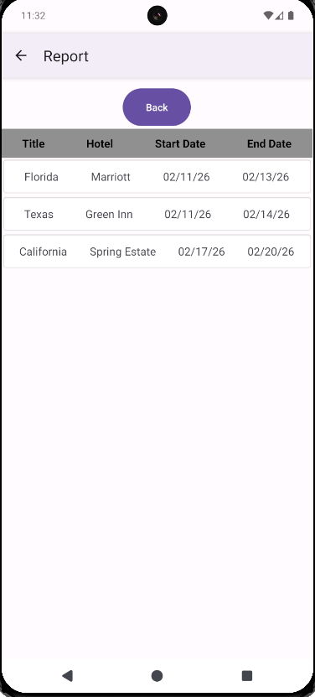

Vacation Details Page
Add Vacation:
- To add a vacation, you must enter a title for the vacation in the title input.
- You must enter the name of the hotel you are staying in for the vacation.
- You must select a start date for the vacation by clicking ‘Select Start Date’ which will open a calendar.
- You much select an end date for the vacation by clicking ‘Select End Date’.
- Then select from the drop-down menu what ‘Transportation Method’ you will use during your vacation.
- Once you have entered these details, click the ‘Save’ button to save your vacation.
Modify Existing Vacation:
- To modify an existing vacation simply change your desired detail then click the ‘Save’ button.
Delete Vacation:
- To delete a vacation, click the ‘Delete’ button. If you are deleting a vacation with excursions, you must delete the excursions first.
Add Excursion:
- To add an excursion, click the ‘+’ button in the bottom right of the screen to go to the ‘Excursion Details’ page. Keep in mind that a vacation must be saved prior to an excursion being added.
View/Modify Existing Excursion:
- To view/modify an existing Excursion, click the title of the excursion (Ex: Disney Land) to go to the ‘Excursion Details' page of that excursion.
Share Vacation:
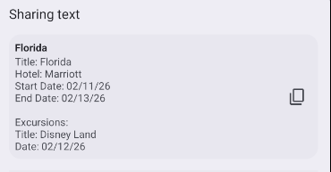
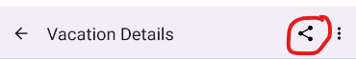
- To share a vacation’s details, click the share button on the top right of the screen (view screenshot). This will export the details of the vacation into a text prompt (view screenshot) which can be shared.
Set Alert for Start/End Date:
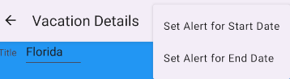
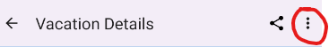
- To set an alert for the start/end date simply click the three dots (view screenshot) on the top right corner of the screen and then select ‘Set Alert for Start Date’ or ‘Set Alert for End Date’ (view screenshot).
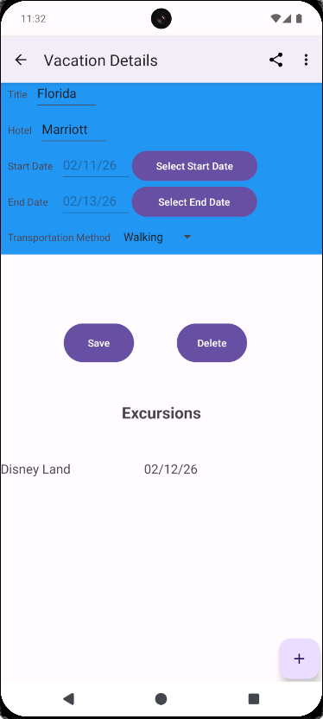

Excursion Details Page
Add Excursion:
- To add an excursion, you must input the excursion’s title in the ‘Title’ input.
- Then you must set a date for the excursion by clicking the ‘Select Date’ button.
- Click the ‘Save’ button to save the newly created excursion.
Modify Existing Excursion:
- To modify an existing excursion, simply modify whichever detail you want (Title or Date) then click the ‘Save’ button.
Delete Excursion:
- To delete an excursion, click the ‘Delete’ button.
Set Alert:
- To set an alert for your excursion, click ‘Set Alert’ in the top right corner of the screen.

